INTRODUCTION TO HMI AND PLC

7.4.2025

Contents

Introduction 3

Main components 3

HMI Touchscreen Panel 4

Home Page 4

Profile Page 5

Control Page 6

Timer Page 7

# Introduction

This system introduces the intern to the introductory phase of learning PLC. Many screens upgraded to properly understand each step from simple button insert to the password input system. Some other element that made this system more structured and systematic is the picture insert which enables the intern to be more creative in order to achieve an accessible system.

# Main components

|  |  |
| --- | --- |
| **Items** | **Function and description** |
| PLC Omron CP2E | Receives input signals ands sends out output signal from CX-Programmer  EXPLAIN MCM KANAK2, FUNCTION |
| POE Switch | Provides extra Ethernet to communicate over the network |
| HMI Delta | Allows operators to monitor, control, and interact with machines or processes in real-time |

# HMI Touchscreen Panel



## Home Page



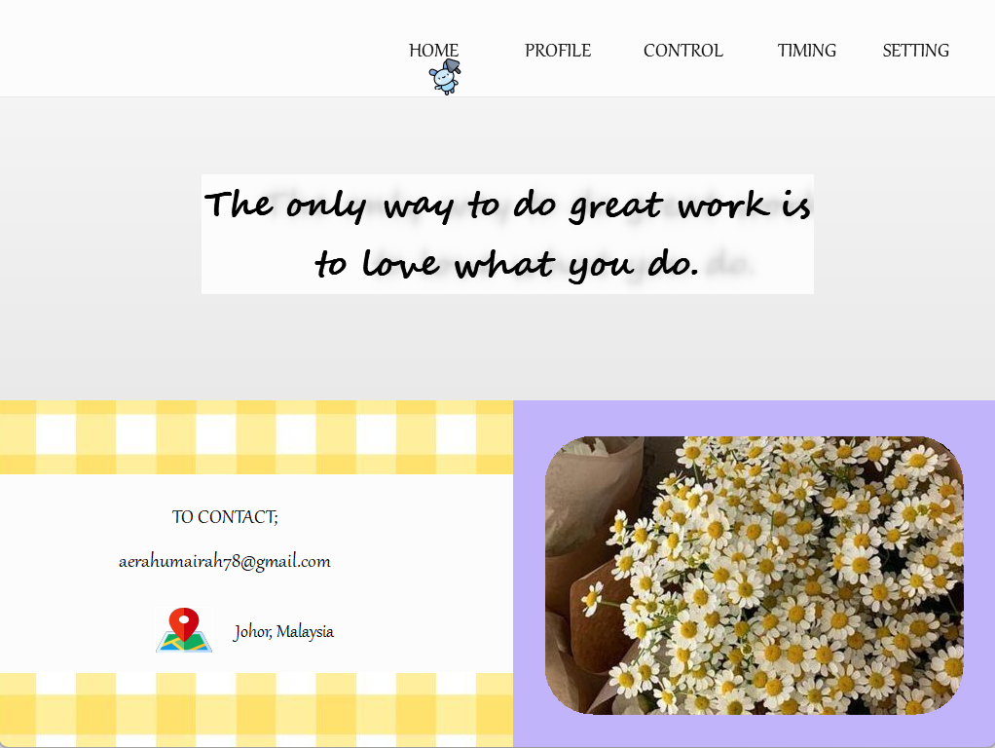

|  |  |
| --- | --- |
| **Item** | **Description** |
|  | Navigation bar, allowing users to switch between different sections of the website or application. |
|  | Motivational quote section, possibly to inspire users or set a positive tone for the website. |
|  | Contact information, providing a way to reach out to the owner of the site. |

## Profile Page

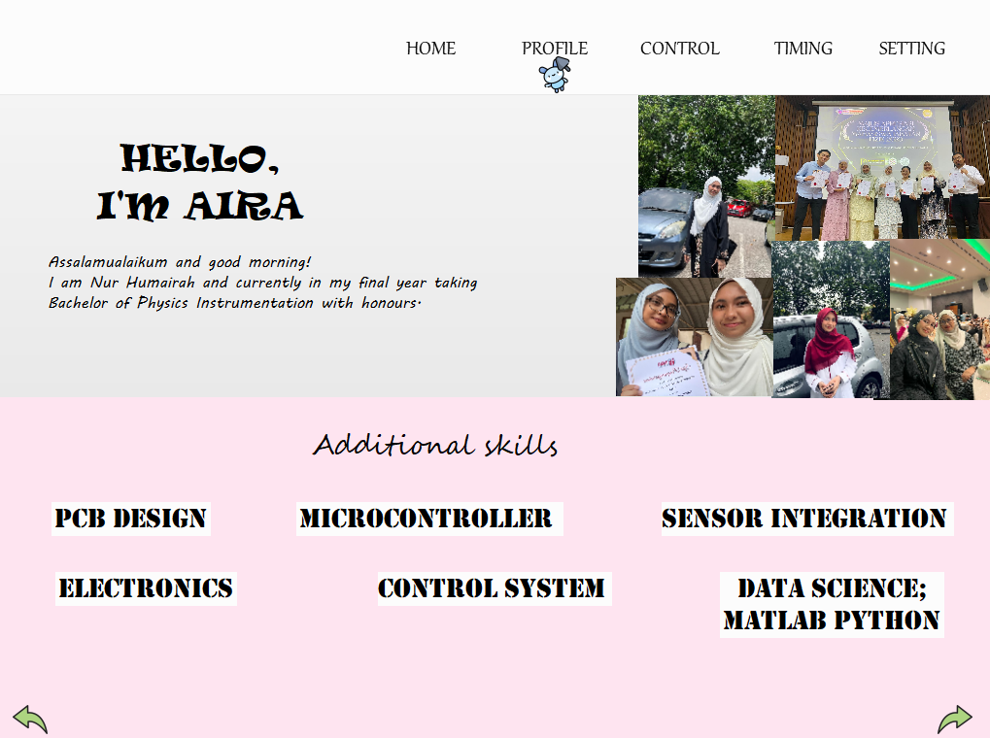

|  |  |
| --- | --- |
| **Item** | **Description** |
|  | Brief profile introduction or bio. |
|  | Introduces the list of technical or professional skills possessed by the user. |
|  | Navigation/back button, used to go back to a previous page. |

## Control Page

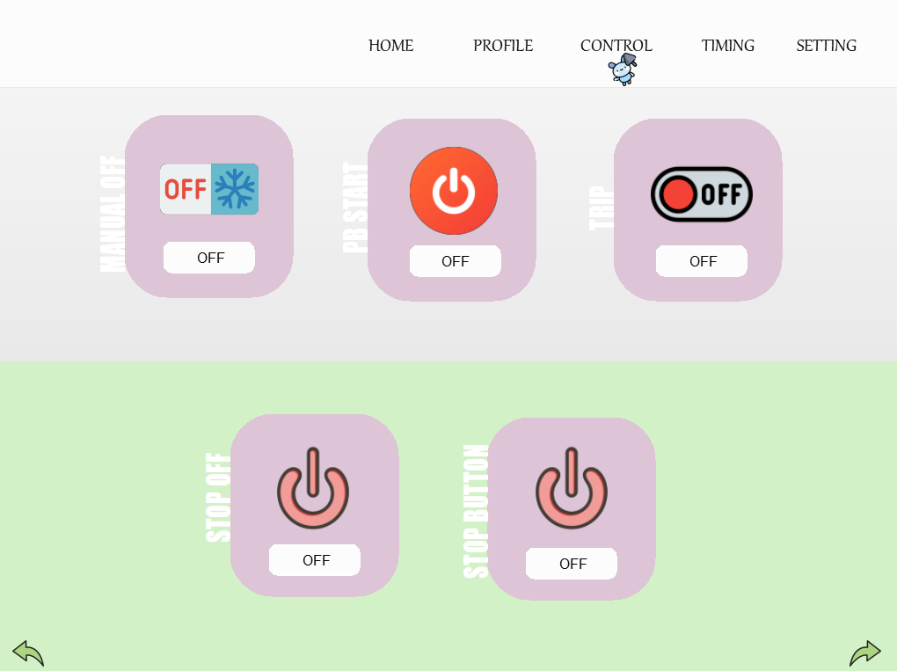

|  |  |
| --- | --- |
| **Item** | **Description** |
|  | Label indicating the function of the control button |
|  | Manual toggle, where the user can turn the associated button system ON/OFF. |
|  | A status display or interactive toggle showing the current state of the button |

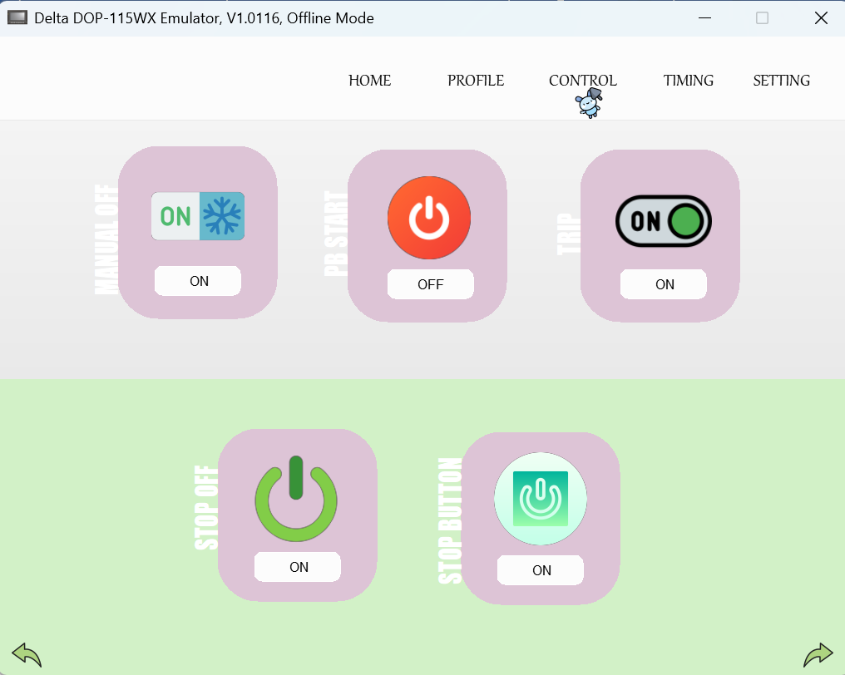

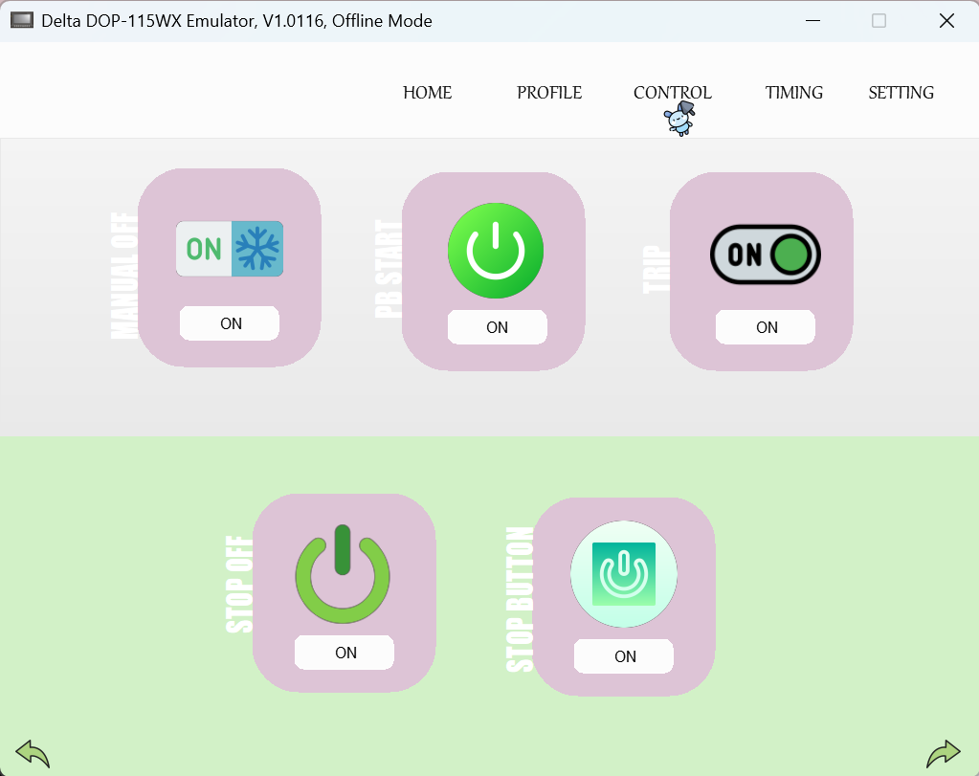

## Timer Page

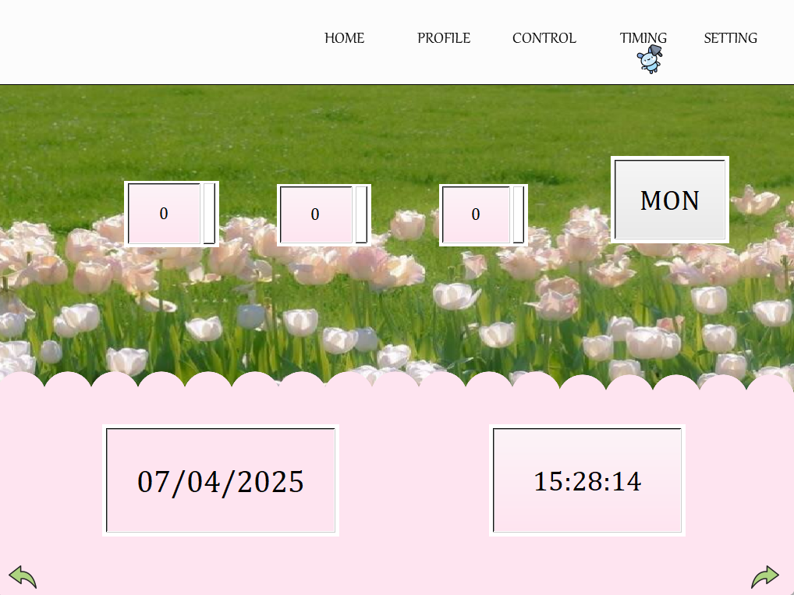

|  |  |
| --- | --- |
| **Item** | **Description** |
|  | Display of ticking clocks of seconds, minutes and hours |
|  | Display of the day |
|  | Display of the date |
|  | Display of current time |